Andrew Sooklall

Questions:

1. Given the provided data, what are three conclusions we can draw about Kickstarter campaigns?

2. What are some limitations of this dataset?

3. What are some other possible tables and/or graphs that we could create?

Answers:

1. A few conclusions we can draw from the recorded data are the following: There are more kickstarter campaigns for theater and play categories and sub-categories (Figures 1 & 2), respectively, compared to the others when looking at the raw numbers, on average there are more successful campaigns than failed/canceled, and the United States is the origin for the majority of the campaigns. Interesting points to note are that there was a massive influx of campaigns in 2014 but since then the amount of campaigns seems to have plateaued and there is a shown correlation between months/seasons and success rates (Figure 3). However, without further information we can’t draw accurate conclusions on those last two points.
2. A few limitations of this data set are that we don’t have data for more recent years to see the effects in the present, we don’t necessarily have context for all our information (eg; age groups targeted, etc.) and we don’t have enough information regarding economic targeting to determine how large an impact economic factors have on whether someone will back a particular kickstarter or not. It should also be kept in mind that this information doesn’t indicated whether the currencies are normalized or whether or not inflation between currency types is accounted for.
3. With the data we have, we can do projection graphs for the best choices with kickstarter categories as well as theoretic times for best launch. A country filter on a date vs. state chart might also be useful for comparing what period of times certain countries respond more amicably to kickstarter campaigns. Obtaining information on whether kickstarters were global targeting or local targeting, and the states within the U.S. for local targeting would be ideal to see the trends for success in local vs. global kickstarters as well as which categories work better in rural vs. suburban and urban areas.

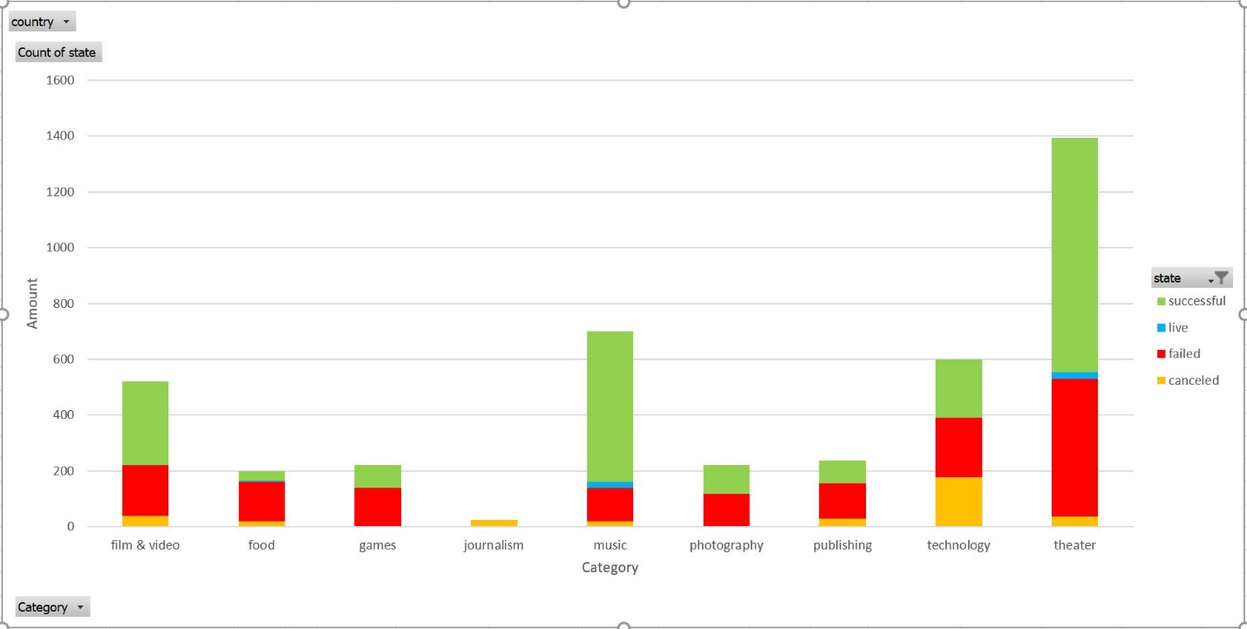

Figure 1. Kickstarter Campaigns Per Category

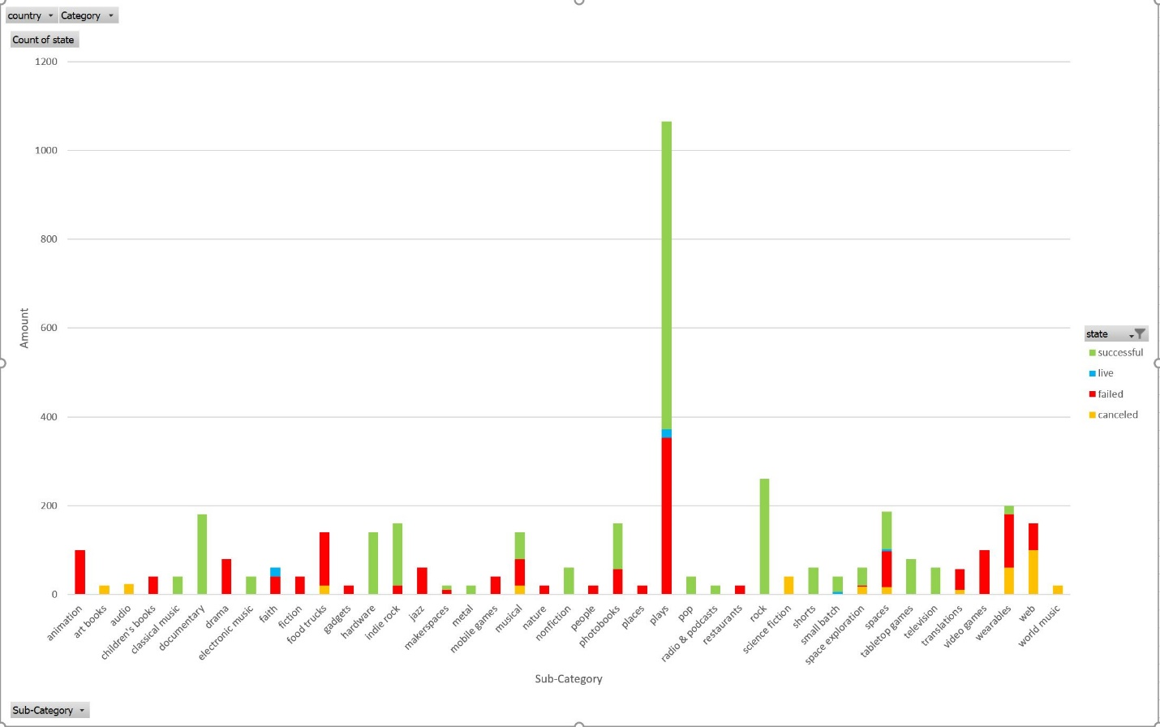

Figure 2. Kickstarter Campaigns Per Sub-Category

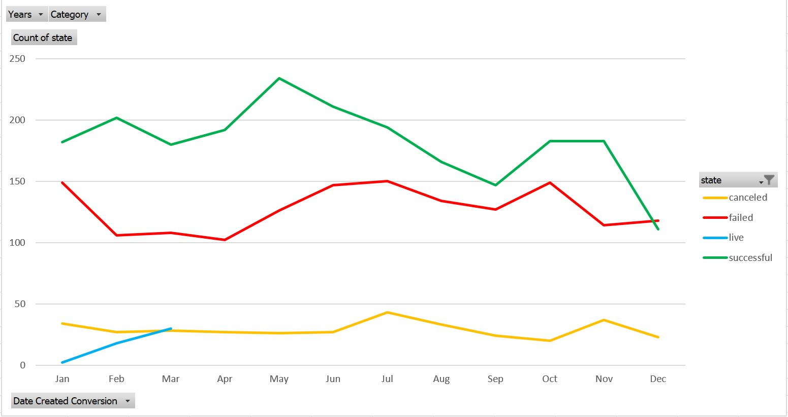

Figure 3. Kickstarter Campaigns Per Month